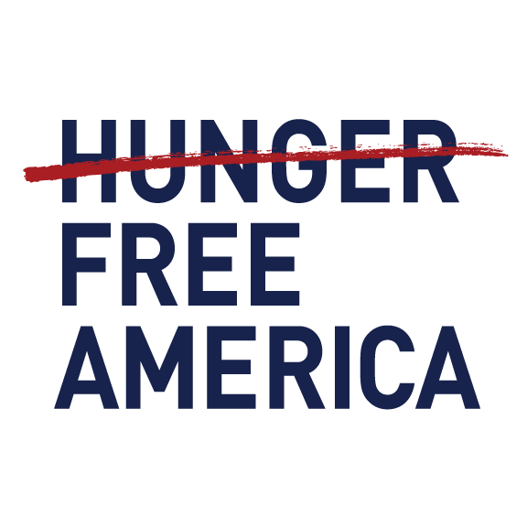

**FOR IMMEDIATE RELEASE CONTACT:**December 19, 2024 Kim Moscaritolo 646-627-7741  
 kmoscaritolo@hungerfreeamerica.org

**New Study: Michigan Hunger Soaring due to Federal Aid Cuts & Inflation**

**More Than 1.3 Million Michigan Residents Food Insecure**

**Michigan Participating in New Summer EBT Program, Which 75% of Recipients Credit with Being Able to Afford More Fruits & Vegetables**

More than 840 thousand Michigan residents didn’t have enough to eat over two one-week periods in August/September of 2024, 53% more than in August/September of 2021, according to an annual Hunger Atlas Report by the nonprofit group Hunger Free America, based on an analysis of federal data. Hunger Free America attributes this surge in hunger to the expiration of several federal programs, including the expanded Child Tax Credit, increased SNAP (formerly called food stamps) allotments, and universal school meals, coupled with the impact of inflation.

According to the USDA food insecurity data - a different way of measuring food hardship analyzed by Hunger Free America – 1,343,779 Michigan residents (13.6%) were found to live in food insecure households between 2021 and 2023. This includes 18.1% of children in the state (385,944), 10.8% of employed adults (515,813), and 7.4% of older Michigan residents (185,210).

This year, in addition to their annual hunger survey, Hunger Free America also conducted a nationwide poll of low-income American households with children to assess the impacts of the USDA’s new Summer EBT program. Summer EBT (also known as SUN Bucks) is a new grocery benefit that launched in the summer of 2024 in 37 states and Washington, D.C. The new benefit allows families with eligible school-aged children in states that opt-into the program to receive $120 per child for groceries over the summer. Thirteen states opted out of participating in the program in its inaugural year, 2024.

The findings of the Summer EBT survey, which can be viewed [HERE](https://hungerfreeamerica.org/en-us/research/summer-ebt-impact-report), showed that 75% of respondents who received the benefits said the benefits helped them buy more fruits and vegetables and/or shop more frequently at farmers’ markets. 73% of respondents who did not receive Summer EBT benefits said the extra benefits would have been very helpful for their family to afford enough food and/or healthy food.

“How can anyone seriously think the economy is healthy when so Americans – spread out among suburban, rural and urban communities in red and blue states alike -- have a tough time affording something as basic as food?” said **Hunger Free America CEO Joel Berg**. “As we say every year when we release this annual report, allowing mass food hardship in a nation with vast food and monetary resources is a political choice. While we are greatly heartened that the new Summer EBT program helped children over a few months, several states opted not to participate. Our reports demonstrate vividly that both our economy and our social safety net are failing in a fundamental way. While our leaders must fight fiercely to protect key food, housing, and health care safety net programs, as well as vocally push to restore the expanded CTC (which previously halved U.S. child poverty), they must also embrace far broader programmatic and systemic reforms that are aspirational and opportunity-boosting.”

Other findings from the Hunger Atlas report:

* 16.8% of children in the U.S. lived in food insecure households in the 2021-2023 time period. The states with the highest rates of food insecure children were Texas (23.8%), Oklahoma (23.2%), Nebraska (22.6%), Georgia (22.4%), and Arkansas (22.4%).
* Nationally, 10.2% of employed adults in the U.S. lived in food insecure households during the three-year time period. The states with the highest rates of food insecurity among employed adults were Arkansas (15.3%), Texas (15.3%), Louisiana (14.2%), Oklahoma (14.1%), and Nebraska (13.0%).
* In the U.S., 8.4% of older Americans, defined as people 60 years and older, lived in food insecure households. Louisiana had the highest rate of food insecurity among older Americans at 13.0%, followed by Mississippi (12.5%), Arkansas (12.2%), Texas (11.9%), and DC (11.3%).

The report includes detailed public policy recommendations at the federal level, state, and city levels, including reauthorizing the Child Tax Credit and expand the EITC for low-income working people, ensure that the Farm Bill strengthens – and doesn’t cut – SNAP and other food assistance programs, ensuring full funding for WIC, processing all SNAP applications within the required 30 days, and increasing school breakfast participation by ensuring all schools provide in-classroom breakfasts to all first period classes.

The full Hunger Atlas report, “**Aid Denied, Hunger Increased**”, is available on Hunger Free America’s website: <https://www.hungerfreeamerica.org/en-us/research/hunger-report-ny-2024>  
  
HFA’s report on its Summer EBT survey of low-income Americans can be found [HERE](https://hungerfreeamerica.org/en-us/research/summer-ebt-impact-report).

###